

Calculator Website

Daniel Krasovski | Software for Global Market 1 (User Interface Design) | 10/04/2019

Contents

Evaluation of original website 2

PERSONAS 3

CHANGES MADE 3

# Evaluation of original website

[www.calculator.com](http://www.calculator.com) Home page:

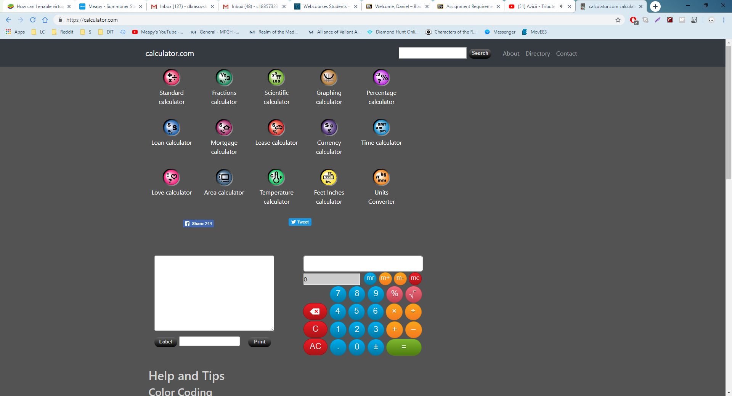

As you can see from the screenshot above, the website looks extremely out of date and un appealing. The colour scheme of grey and dark grey, followed with all the different colours of the different pages add to the out of date feel of the website. By using the website, we see more out of date features. Such as not having consistent page layout, colour schemes and some of the pages sizes are ether too small or too big:

<https://calculator.com/pantaserv/makecalc>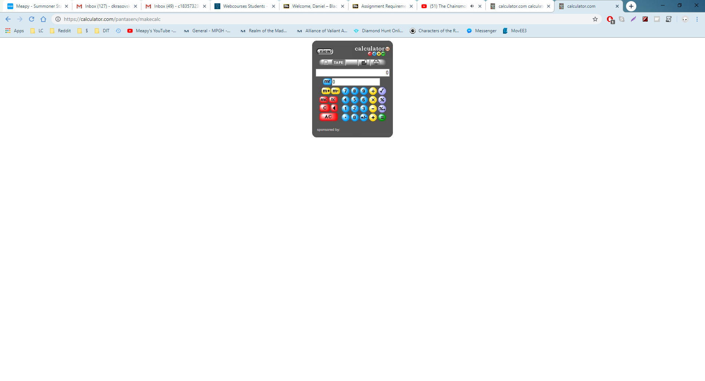

## PERSONAS

You might like the photo on the cover page as much as we do, but if it’s not ideal for your report, it’s easy to replace it with your own.

Just delete the placeholder picture. Then, on the Insert tab, click Picture to select one from your files.

## cHANGES MADE

Before starting the website I had to come up with a colour scheme, after some thought I came up with grey and a dark turquoise colour. I decided to keep the website extremely simple and only have one specific task that you can do on each page.

I started off with remaking the home page. Keeping with the current trend of simplicity, The home page is extremely simple. It has the page and below the title, it has a search bar in the middle of screen. However, the search bar is not functional at the current moment. Home page comparison:

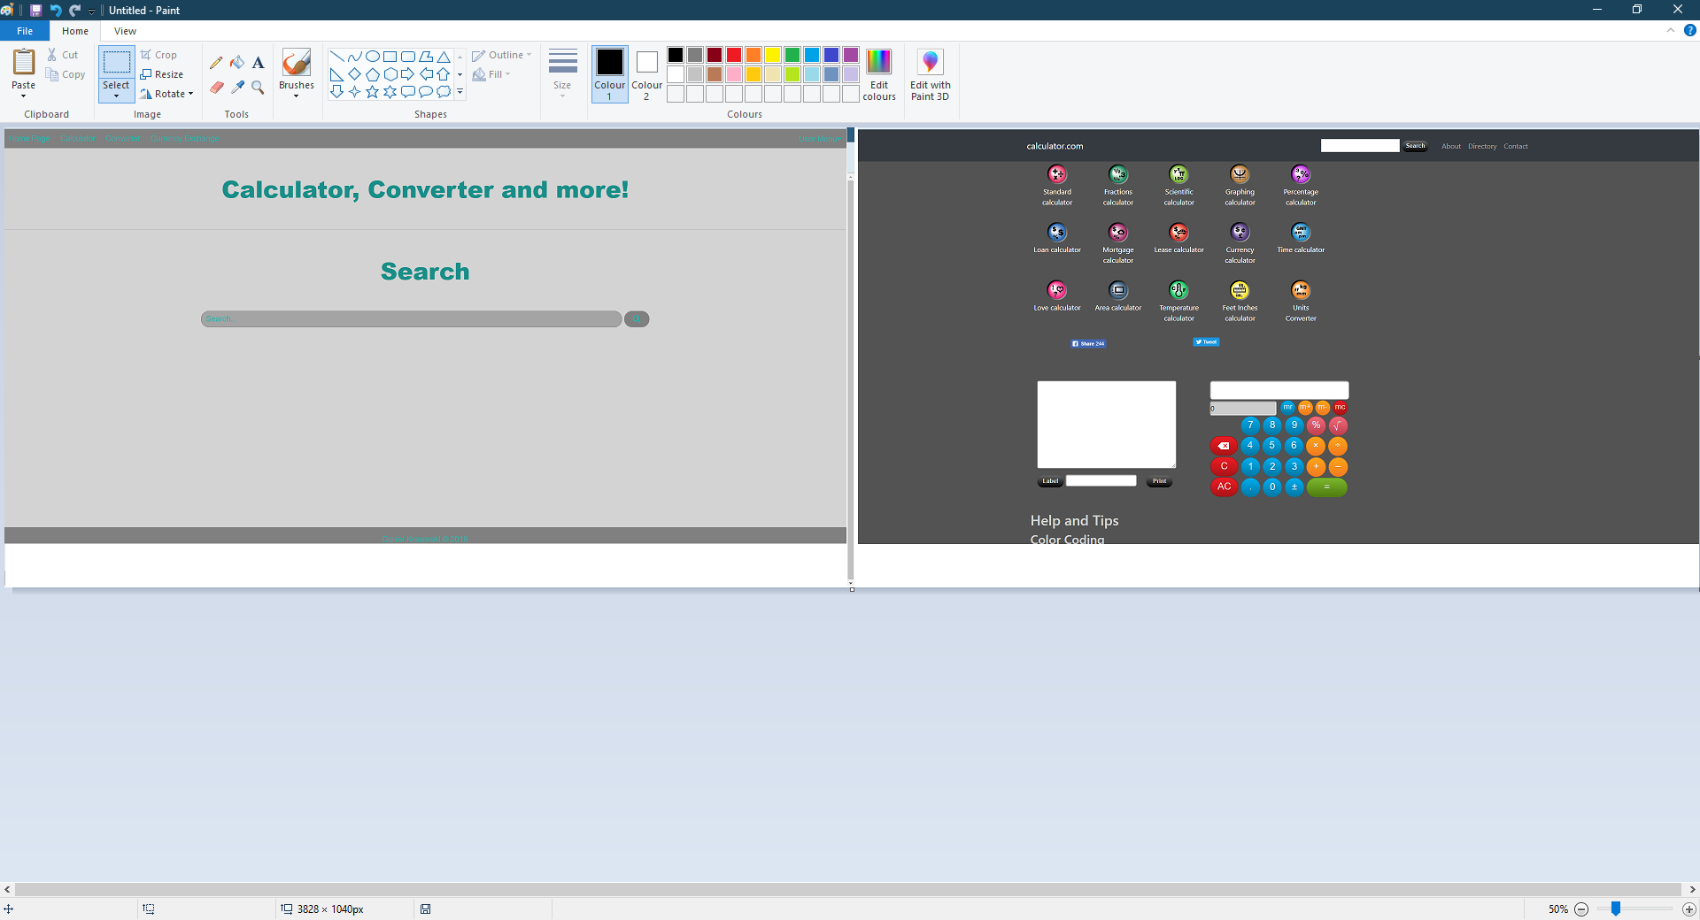

For the second page, I remade the standalone calculator page. Keeping the page layout and colour scheme the same, I added the calculator which is full size on the web page. The user can click the buttons on the website or type them in, in the output bar. However, to calculate, you need to press the = sign button on the webpage. 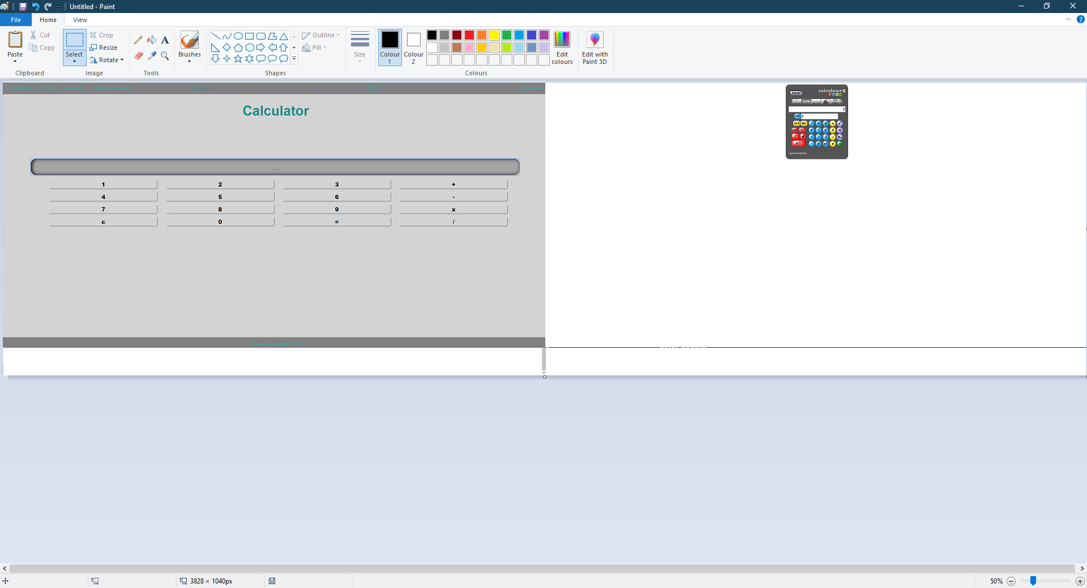

For the third page, I remade the length converter page, which can convert distances from the metric system to the imperial system and vice versa. To choose what you want to convert, you just pick it from the dropdown menu and then enter the value into the box and click the convert button. It will then show the converted figure to the right of the button.

